*1. Профайлинг для различных видов сортировок массива на 250000 записей (int). GC Parallel mode.*

*-XX:+UseParallelGC -Xmx12m -Xms12m -Xlog:gc:log.txt*

Тайм коды сортировок:

Сортировка слиянием

MergeSort Начало сортировки - 08:53:44.468012500

MergeSort Конец сортировки - 08:53:44.671029800

Дельта = 203мс

Сортировка вставкой

InsertSort Начало сортировки - 08:54:03.517654400

InsertSort Конец сортировки - 08:54:10.596716400

Дельта = 7с 79мс

Сортировка пузырьком

BubbleSort Начало сортировки - 08:54:24.690325900

BubbleSort Конец сортировки - 08:56:37.622253800

Дельта = 2мин 13с

При выполнении сортировки происходила как малая так и большая сборка мусора:

[0.013s][info][gc] Using Parallel  
[1.014s][info][gc] GC(0) Pause Young (Allocation Failure) 3M->1M(11M) 2.856ms  
[2.317s][info][gc] GC(1) Pause Young (Allocation Failure) 4M->2M(11M) 2.675ms  
[2.391s][info][gc] GC(2) Pause Young (Allocation Failure) 5M->3M(11M) 1.971ms  
[2.448s][info][gc] GC(3) Pause Young (Allocation Failure) 6M->4M(11M) 2.638ms  
[2.478s][info][gc] GC(4) Pause Young (Allocation Failure) 7M->5M(11M) 3.312ms  
[3.425s][info][gc] GC(5) Pause Young (Allocation Failure) 8M->6M(10M) 2.885ms  
[3.605s][info][gc] GC(6) Pause Young (Allocation Failure) 8M->7M(11M) 2.777ms  
[3.619s][info][gc] GC(7) Pause Full (Ergonomics) 7M->4M(11M) 13.967ms  
[7.684s][info][gc] GC(8) Pause Young (Allocation Failure) 6M->4M(11M) 2.200ms  
[19.684s][info][gc] GC(9) Pause Young (Allocation Failure) 6M->4M(11M) 2.308ms  
[27.696s][info][gc] GC(10) Pause Young (Allocation Failure) 6M->5M(11M) 1.893ms  
[41.996s][info][gc] GC(11) Pause Young (Allocation Failure) 7M->5M(11M) 0.632ms  
[42.001s][info][gc] GC(12) Pause Young (Allocation Failure) 7M->6M(11M) 0.435ms  
[42.007s][info][gc] GC(13) Pause Young (Allocation Failure) 8M->6M(11M) 0.588ms  
[42.030s][info][gc] GC(14) Pause Full (Ergonomics) 6M->6M(11M) 22.923ms  
[42.047s][info][gc] GC(15) Pause Young (Allocation Failure) 8M->6M(11M) 0.556ms  
[42.061s][info][gc] GC(16) Pause Young (Allocation Failure) 8M->6M(11M) 0.299ms  
[42.064s][info][gc] GC(17) Pause Young (Allocation Failure) 8M->6M(11M) 0.320ms  
[42.075s][info][gc] GC(18) Pause Full (Ergonomics) 6M->6M(11M) 11.270ms  
[42.089s][info][gc] GC(19) Pause Full (Ergonomics) 8M->6M(11M) 10.516ms  
[42.102s][info][gc] GC(20) Pause Full (Ergonomics) 8M->6M(11M) 10.731ms  
[42.117s][info][gc] GC(21) Pause Full (Ergonomics) 8M->6M(11M) 10.716ms  
[42.130s][info][gc] GC(22) Pause Full (Ergonomics) 8M->6M(11M) 9.900ms  
[42.143s][info][gc] GC(23) Pause Full (Ergonomics) 8M->6M(11M) 10.500ms  
[42.156s][info][gc] GC(24) Pause Full (Ergonomics) 8M->6M(11M) 10.250ms  
[42.170s][info][gc] GC(25) Pause Full (Ergonomics) 8M->6M(11M) 10.372ms  
[42.183s][info][gc] GC(26) Pause Full (Ergonomics) 8M->6M(11M) 9.668ms  
[42.196s][info][gc] GC(27) Pause Full (Ergonomics) 8M->6M(11M) 9.907ms  
[45.732s][info][gc] GC(28) Pause Full (Ergonomics) 8M->5M(11M) 12.860ms  
[61.046s][info][gc] GC(29) Pause Young (Allocation Failure) 6M->5M(11M) 0.419ms  
[70.730s][info][gc] GC(30) Pause Young (Allocation Failure) 7M->5M(11M) 0.882ms  
[82.219s][info][gc] GC(31) Pause Young (Allocation Failure) 6M->5M(11M) 0.379ms  
[91.743s][info][gc] GC(32) Pause Young (Allocation Failure) 7M->6M(11M) 0.445ms  
[109.749s][info][gc] GC(33) Pause Young (Allocation Failure) 8M->6M(11M) 0.420ms  
[129.715s][info][gc] GC(34) Pause Young (Allocation Failure) 8M->6M(11M) 0.399ms  
[148.764s][info][gc] GC(35) Pause Young (Allocation Failure) 8M->6M(11M) 0.435ms  
[166.786s][info][gc] GC(36) Pause Young (Allocation Failure) 8M->6M(11M) 0.401ms  
[185.794s][info][gc] GC(37) Pause Young (Allocation Failure) 8M->6M(11M) 0.351ms  
[203.811s][info][gc] GC(38) Pause Young (Allocation Failure) 8M->6M(11M) 0.389ms

Была замечена странная особенность, если не использовать Visual VM, то GC использует только малую сборку мусора, при использовании Visual VM, GC запускает и большую.

- График по времени использования ЦП и Heap при выполнении операций сортировки, слева-направо: сортировка слиянием, сортировка вставкой, сортировка пузырьком.

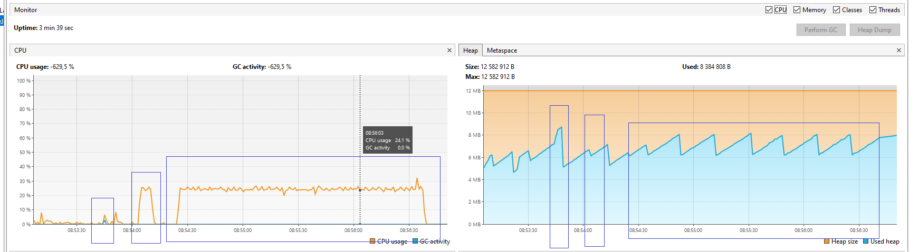

*2. Профайлинг для различных видов сортировок массива на 250000 записей (int). GC G1 mode.*

*-XX:+UseG1GC -Xmx12m -Xms12m -Xlog:gc:log.txt*

Тайм коды сортировок:

Сортировка слиянием

MergeSort Начало сортировки - 09:19:45.339665800

MergeSort Конец сортировки - 09:19:45.473052800

Дельта = 134мс

Сортировка вставкой

InsertSort Начало сортировки - 09:20:08.321591700

InsertSort Конец сортировки - 09:20:15.200971600

Дельта = 6с 880мс

Сортировка пузырьком

BubbleSort Начало сортировки - 09:20:37.376515400

BubbleSort Конец сортировки - 09:22:51.309463900

Дельта = 2мин 14с

Протокол сборщика мусора:

[0.013s][info][gc] Using G1  
[3.257s][info][gc] GC(0) Pause Young (Normal) (G1 Evacuation Pause) 3M->2M(12M) 4.005ms  
[3.309s][info][gc] GC(1) Pause Young (Normal) (G1 Evacuation Pause) 3M->2M(12M) 2.542ms  
[3.333s][info][gc] GC(2) Pause Young (Normal) (G1 Evacuation Pause) 3M->3M(12M) 1.182ms  
[3.345s][info][gc] GC(3) Pause Young (Normal) (G1 Evacuation Pause) 4M->3M(12M) 1.167ms  
[3.405s][info][gc] GC(4) Pause Young (Normal) (G1 Evacuation Pause) 5M->3M(12M) 1.391ms  
[3.453s][info][gc] GC(5) Pause Young (Normal) (G1 Evacuation Pause) 5M->3M(12M) 1.560ms  
[3.471s][info][gc] GC(6) Pause Young (Normal) (G1 Evacuation Pause) 5M->4M(12M) 2.595ms  
[3.493s][info][gc] GC(7) Pause Young (Normal) (G1 Evacuation Pause) 6M->5M(12M) 2.944ms  
[4.416s][info][gc] GC(8) Pause Young (Normal) (G1 Evacuation Pause) 6M->5M(12M) 1.053ms  
[4.492s][info][gc] GC(9) Pause Young (Normal) (G1 Evacuation Pause) 6M->5M(12M) 0.946ms  
[4.544s][info][gc] GC(10) Pause Young (Normal) (G1 Evacuation Pause) 6M->5M(12M) 1.317ms  
[4.675s][info][gc] GC(11) Pause Young (Normal) (G1 Evacuation Pause) 6M->5M(12M) 1.651ms  
[4.747s][info][gc] GC(12) Pause Young (Concurrent Start) (G1 Evacuation Pause) 6M->6M(12M) 2.828ms  
[4.747s][info][gc] GC(13) Concurrent Mark Cycle  
[4.756s][info][gc] GC(13) Pause Remark 6M->6M(12M) 1.470ms  
[4.760s][info][gc] GC(13) Pause Cleanup 6M->6M(12M) 0.048ms  
[4.760s][info][gc] GC(13) Concurrent Mark Cycle 13.087ms  
[4.802s][info][gc] GC(14) Pause Young (Prepare Mixed) (G1 Evacuation Pause) 7M->6M(12M) 1.594ms  
[7.828s][info][gc] GC(15) Pause Young (Mixed) (G1 Evacuation Pause) 7M->4M(12M) 7.709ms  
[23.897s][info][gc] GC(16) Pause Young (Normal) (G1 Evacuation Pause) 6M->4M(12M) 1.904ms  
[24.256s][info][gc] GC(17) Pause Young (Concurrent Start) (G1 Humongous Allocation) 4M->4M(12M) 1.864ms  
[24.256s][info][gc] GC(18) Concurrent Undo Cycle  
[24.256s][info][gc] GC(18) Concurrent Undo Cycle 0.101ms  
[36.832s][info][gc] GC(19) Pause Young (Normal) (G1 Evacuation Pause) 7M->5M(12M) 4.369ms  
[43.624s][info][gc] GC(20) Pause Young (Concurrent Start) (G1 Humongous Allocation) 6M->5M(12M) 1.909ms  
[43.624s][info][gc] GC(21) Concurrent Mark Cycle  
[43.633s][info][gc] GC(22) Pause Young (Normal) (G1 Evacuation Pause) 8M->6M(12M) 1.791ms  
[43.639s][info][gc] GC(21) Pause Remark 7M->7M(12M) 4.033ms  
[43.643s][info][gc] GC(21) Pause Cleanup 7M->7M(12M) 0.030ms  
[43.649s][info][gc] GC(23) Pause Young (Normal) (G1 Evacuation Pause) 7M->6M(12M) 1.697ms  
[43.649s][info][gc] GC(21) Concurrent Mark Cycle 24.508ms  
[43.661s][info][gc] GC(24) Pause Young (Normal) (G1 Evacuation Pause) 7M->6M(12M) 1.822ms  
[43.671s][info][gc] GC(25) Pause Young (Concurrent Start) (G1 Evacuation Pause) 7M->6M(12M) 1.928ms  
[43.671s][info][gc] GC(26) Concurrent Mark Cycle  
[43.678s][info][gc] GC(27) Pause Young (Normal) (G1 Evacuation Pause) 7M->6M(12M) 2.135ms  
[43.683s][info][gc] GC(26) Pause Remark 7M->7M(12M) 2.159ms  
[43.687s][info][gc] GC(28) Pause Young (Normal) (G1 Evacuation Pause) 7M->6M(12M) 1.892ms  
[43.690s][info][gc] GC(29) Pause Young (Normal) (G1 Evacuation Pause) 7M->6M(12M) 1.367ms  
[43.691s][info][gc] GC(26) Pause Cleanup 6M->6M(12M) 0.149ms  
[43.691s][info][gc] GC(26) Concurrent Mark Cycle 19.852ms  
[43.694s][info][gc] GC(30) Pause Young (Normal) (G1 Evacuation Pause) 7M->6M(12M) 1.492ms  
[43.697s][info][gc] GC(31) Pause Young (Concurrent Start) (G1 Evacuation Pause) 7M->6M(12M) 1.701ms  
[43.697s][info][gc] GC(32) Concurrent Mark Cycle  
[43.700s][info][gc] GC(33) Pause Young (Normal) (G1 Evacuation Pause) 7M->7M(12M) 1.336ms  
[43.703s][info][gc] GC(34) Pause Young (Normal) (G1 Evacuation Pause) 8M->7M(12M) 1.194ms  
[43.707s][info][gc] GC(35) Pause Young (Normal) (G1 Evacuation Pause) 7M->7M(12M) 1.347ms  
[43.710s][info][gc] GC(36) Pause Young (Normal) (G1 Evacuation Pause) 8M->7M(12M) 0.977ms  
[43.714s][info][gc] GC(32) Pause Remark 7M->7M(12M) 3.575ms  
[43.716s][info][gc] GC(37) Pause Young (Normal) (G1 Evacuation Pause) 8M->7M(12M) 1.003ms  
[43.719s][info][gc] GC(38) Pause Young (Normal) (G1 Evacuation Pause) 8M->7M(12M) 0.893ms  
[43.720s][info][gc] GC(32) Pause Cleanup 8M->8M(12M) 0.100ms  
[43.721s][info][gc] GC(32) Concurrent Mark Cycle 23.107ms  
[43.722s][info][gc] GC(39) Pause Young (Normal) (G1 Evacuation Pause) 8M->7M(12M) 0.762ms  
[43.724s][info][gc] GC(40) Pause Young (Concurrent Start) (G1 Evacuation Pause) 8M->7M(12M) 0.819ms  
[43.724s][info][gc] GC(41) Concurrent Mark Cycle  
[43.727s][info][gc] GC(42) Pause Young (Normal) (G1 Evacuation Pause) 8M->7M(12M) 0.935ms  
[43.730s][info][gc] GC(43) Pause Young (Normal) (G1 Evacuation Pause) 8M->7M(12M) 0.945ms  
[43.732s][info][gc] GC(44) Pause Young (Normal) (G1 Evacuation Pause) 8M->7M(12M) 0.953ms  
[43.734s][info][gc] GC(45) Pause Young (Normal) (G1 Evacuation Pause) 8M->7M(12M) 0.257ms  
[43.739s][info][gc] GC(41) Pause Remark 8M->8M(12M) 3.223ms  
[43.740s][info][gc] GC(46) Pause Young (Normal) (G1 Evacuation Pause) 8M->7M(12M) 0.934ms  
[43.743s][info][gc] GC(47) Pause Young (Normal) (G1 Evacuation Pause) 8M->7M(12M) 0.902ms  
[43.745s][info][gc] GC(41) Pause Cleanup 8M->8M(12M) 0.151ms  
[43.745s][info][gc] GC(41) Concurrent Mark Cycle 20.795ms  
[43.746s][info][gc] GC(48) Pause Young (Prepare Mixed) (G1 Evacuation Pause) 8M->7M(12M) 0.825ms  
[43.750s][info][gc] GC(49) Pause Young (Mixed) (G1 Preventive Collection) 8M->7M(12M) 2.061ms  
[43.753s][info][gc] GC(50) Pause Young (Concurrent Start) (G1 Humongous Allocation) 8M->7M(12M) 0.952ms  
[43.753s][info][gc] GC(51) Concurrent Mark Cycle  
[43.762s][info][gc] GC(51) Pause Remark 8M->8M(12M) 2.263ms  
[43.763s][info][gc] GC(51) Pause Cleanup 8M->8M(12M) 0.006ms  
[43.763s][info][gc] GC(51) Concurrent Mark Cycle 10.110ms  
[46.872s][info][gc] GC(52) Pause Young (Normal) (G1 Evacuation Pause) 9M->6M(12M) 1.376ms  
[55.899s][info][gc] GC(53) Pause Young (Concurrent Start) (G1 Evacuation Pause) 7M->6M(12M) 2.081ms  
[55.899s][info][gc] GC(54) Concurrent Mark Cycle  
[55.912s][info][gc] GC(54) Pause Remark 6M->6M(12M) 2.762ms  
[55.916s][info][gc] GC(54) Pause Cleanup 6M->6M(12M) 0.171ms  
[55.916s][info][gc] GC(54) Concurrent Mark Cycle 17.565ms  
[64.897s][info][gc] GC(55) Pause Young (Normal) (G1 Evacuation Pause) 7M->5M(12M) 2.069ms  
[66.605s][info][gc] GC(56) Pause Young (Concurrent Start) (G1 Humongous Allocation) 6M->5M(12M) 1.005ms  
[66.605s][info][gc] GC(57) Concurrent Mark Cycle  
[66.616s][info][gc] GC(57) Pause Remark 6M->6M(12M) 2.732ms  
[66.621s][info][gc] GC(57) Pause Cleanup 6M->6M(12M) 0.024ms  
[66.621s][info][gc] GC(57) Concurrent Mark Cycle 15.525ms  
[84.885s][info][gc] GC(58) Pause Young (Normal) (G1 Evacuation Pause) 8M->5M(12M) 2.321ms  
[95.660s][info][gc] GC(59) Pause Young (Concurrent Start) (G1 Humongous Allocation) 7M->5M(12M) 1.233ms  
[95.660s][info][gc] GC(60) Concurrent Mark Cycle  
[95.671s][info][gc] GC(60) Pause Remark 6M->6M(12M) 2.526ms  
[95.675s][info][gc] GC(60) Pause Cleanup 6M->6M(12M) 0.040ms  
[95.676s][info][gc] GC(60) Concurrent Mark Cycle 16.239ms  
[113.904s][info][gc] GC(61) Pause Young (Normal) (G1 Evacuation Pause) 8M->6M(12M) 1.655ms  
[122.912s][info][gc] GC(62) Pause Young (Concurrent Start) (G1 Evacuation Pause) 7M->6M(12M) 1.139ms  
[122.912s][info][gc] GC(63) Concurrent Mark Cycle  
[122.922s][info][gc] GC(63) Pause Remark 7M->7M(12M) 2.529ms  
[122.926s][info][gc] GC(63) Pause Cleanup 7M->7M(12M) 0.032ms  
[122.926s][info][gc] GC(63) Concurrent Mark Cycle 13.552ms  
[131.926s][info][gc] GC(64) Pause Young (Normal) (G1 Evacuation Pause) 7M->6M(12M) 1.575ms  
[141.883s][info][gc] GC(65) Pause Young (Concurrent Start) (G1 Evacuation Pause) 7M->6M(12M) 1.396ms  
[141.883s][info][gc] GC(66) Concurrent Mark Cycle  
[141.893s][info][gc] GC(66) Pause Remark 7M->7M(12M) 2.619ms  
[141.897s][info][gc] GC(66) Pause Cleanup 7M->7M(12M) 0.150ms  
[141.897s][info][gc] GC(66) Concurrent Mark Cycle 14.318ms  
[150.943s][info][gc] GC(67) Pause Young (Normal) (G1 Evacuation Pause) 7M->6M(12M) 1.159ms  
[159.952s][info][gc] GC(68) Pause Young (Concurrent Start) (G1 Evacuation Pause) 7M->7M(12M) 1.266ms  
[159.953s][info][gc] GC(69) Concurrent Mark Cycle  
[159.962s][info][gc] GC(69) Pause Remark 7M->7M(12M) 2.487ms  
[159.966s][info][gc] GC(69) Pause Cleanup 7M->7M(12M) 0.147ms  
[159.966s][info][gc] GC(69) Concurrent Mark Cycle 13.635ms  
[169.964s][info][gc] GC(70) Pause Young (Normal) (G1 Evacuation Pause) 8M->6M(12M) 1.571ms  
[178.972s][info][gc] GC(71) Pause Young (Concurrent Start) (G1 Evacuation Pause) 7M->7M(12M) 1.424ms  
[178.972s][info][gc] GC(72) Concurrent Mark Cycle  
[178.982s][info][gc] GC(72) Pause Remark 7M->7M(12M) 2.377ms  
[178.986s][info][gc] GC(72) Pause Cleanup 7M->7M(12M) 0.027ms  
[178.986s][info][gc] GC(72) Concurrent Mark Cycle 13.462ms  
[188.908s][info][gc] GC(73) Pause Young (Normal) (G1 Evacuation Pause) 8M->7M(12M) 1.209ms  
[197.989s][info][gc] GC(74) Pause Young (Concurrent Start) (G1 Evacuation Pause) 8M->7M(12M) 1.256ms  
[197.989s][info][gc] GC(75) Concurrent Mark Cycle  
[198.000s][info][gc] GC(75) Pause Remark 7M->7M(12M) 2.275ms  
[198.003s][info][gc] GC(75) Pause Cleanup 7M->7M(12M) 0.156ms  
[198.003s][info][gc] GC(75) Concurrent Mark Cycle 14.271ms  
[206.994s][info][gc] GC(76) Pause Young (Normal) (G1 Evacuation Pause) 8M->7M(12M) 1.333ms  
[217.001s][info][gc] GC(77) Pause Young (Concurrent Start) (G1 Evacuation Pause) 8M->7M(12M) 1.273ms  
[217.001s][info][gc] GC(78) Concurrent Mark Cycle  
[217.013s][info][gc] GC(78) Pause Remark 7M->7M(12M) 3.834ms  
[217.017s][info][gc] GC(78) Pause Cleanup 7M->7M(12M) 0.209ms  
[217.017s][info][gc] GC(78) Concurrent Mark Cycle 15.854ms  
[225.009s][info][gc] GC(79) Pause Young (Normal) (G1 Evacuation Pause) 8M->7M(12M) 1.502ms  
[234.935s][info][gc] GC(80) Pause Young (Concurrent Start) (G1 Evacuation Pause) 8M->6M(12M) 1.701ms  
[234.935s][info][gc] GC(81) Concurrent Mark Cycle  
[234.952s][info][gc] GC(81) Pause Remark 6M->6M(12M) 5.652ms  
[234.958s][info][gc] GC(81) Pause Cleanup 6M->6M(12M) 0.197ms  
[234.958s][info][gc] GC(81) Concurrent Mark Cycle 22.946ms  
[246.026s][info][gc] GC(82) Pause Young (Normal) (G1 Evacuation Pause) 8M->6M(12M) 2.034ms

- График по времени использования ЦП и Heap при выполнении операций сортировки, слева-направо: сортировка слиянием, сортировка вставкой, сортировка пузырьком.

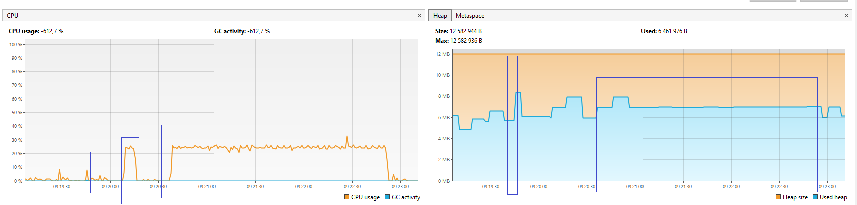

*3. Профайлинг для различных видов сортировок массива на 250000 записей (int). GC ZGC  mode (100 Mb).*

*-XX:+UseZGC -Xmx100m -Xms100m -Xlog:gc:log.txt*

Тайм коды сортировок:

Сортировка слиянием

MergeSort Начало сортировки - 09:49:02.413271700

MergeSort Конец сортировки - 09:49:02.505103100

Сортировка вставкой

InsertSort Начало сортировки - 09:49:37.738318300

InsertSort Конец сортировки - 09:49:44.781467900

Сортировка пузырьком

BubbleSort Начало сортировки - 09:50:01.868906300

BubbleSort Конец сортировки - 09:52:17.223459100

Протокол сборщика мусора:

[0.021s][info][gc] Using The Z Garbage Collector  
[4.678s][info][gc] GC(0) Garbage Collection (Warmup) 12M(12%)->8M(8%)  
[5.793s][info][gc] GC(1) Garbage Collection (Warmup) 20M(20%)->8M(8%)  
[49.974s][info][gc] GC(2) Garbage Collection (Warmup) 44M(44%)->26M(26%)  
[93.179s][info][gc] GC(3) Garbage Collection (Proactive) 36M(36%)->10M(10%)  
[132.173s][info][gc] GC(4) Garbage Collection (Proactive) 20M(20%)->14M(14%)  
[209.279s][info][gc] GC(5) Garbage Collection (Proactive) 24M(24%)->12M(12%)

При использовании сборщика мусора в режиме Z с выделением памяти 100 Мб GC выполнил всего шесть операций по оптимизации кучи, что довольно мало по сравнению с режимами ParallelGC и G1GC, что должно приводит к меньшему времени отклика по сравнению с этими режимами.

- График по времени использования ЦП и Heap при выполнении операций сортировки, слева-направо: сортировка слиянием, сортировка вставкой, сортировка пузырьком.

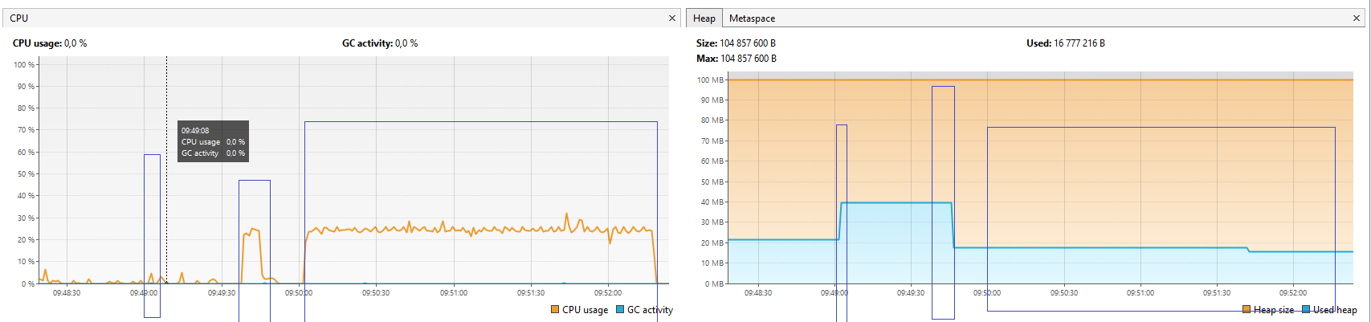

*3a. Профайлинг для различных видов сортировок массива на 250000 записей (int). GC ZGC mode (500 Mb).*

*-XX:+UseZGC -Xmx500m -Xms500m -Xlog:gc:log.txt*

Протокол сборщика мусора:

[0.046s][info][gc] Using The Z Garbage Collector  
[38.318s][info][gc] GC(0) Garbage Collection (Warmup) 50M(10%)->38M(8%)

- График по времени использования ЦП и Heap при выполнении операций сортировки, слева-направо: сортировка слиянием, сортировка вставкой, сортировка пузырьком.

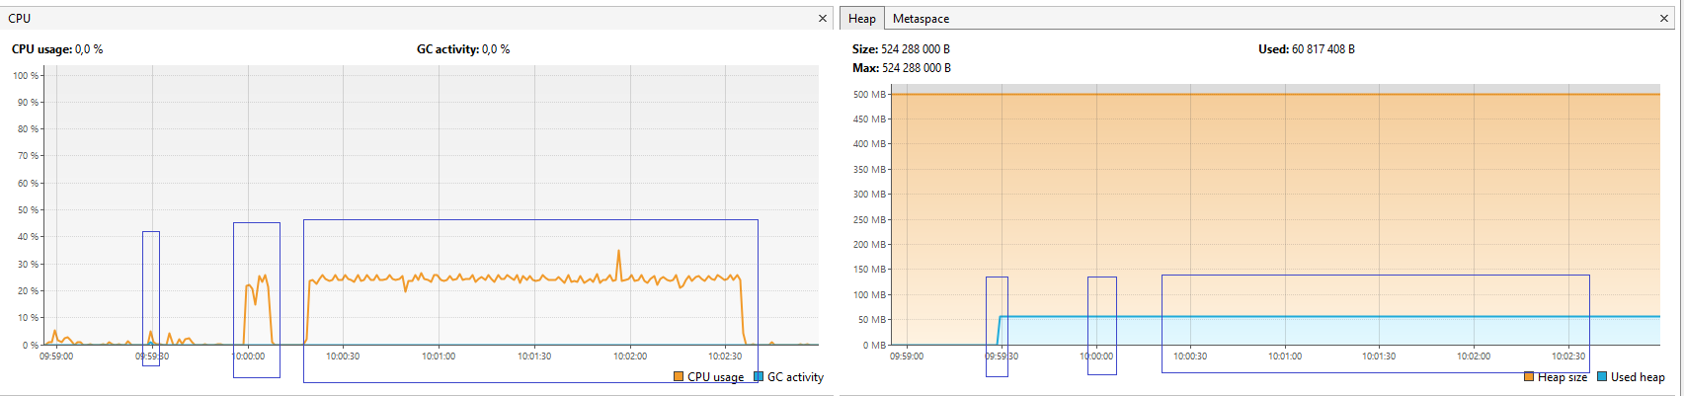

При использовании сборщика мусора в режиме Z с выделением памяти 500 Мб GC выполнил всего одну операцию – “Warmup” (прогрев) и в дальнейшем сборщик мусора не вызывался, что говорит о достаточном количестве памяти в куче и отсутствии необходимости ее уплотнять. Т.е., сборщик мусора на всем протяжении выполнения программ сортировки не вносил задержек своей работой, что может быть важно для некоторых задач.